Experiment 5: Develop a program to deploy smart street light system using LDR with Arduino Board
Date : 02.09.2025
Aim:
To develop the program to deploy smart street light system using LDR sensorwith Arduino Board.
Components Required:
S.No | Components Name | Range/Rating | Quantity
1 | Universal Bread Board |  | 1
2 | Arduino Uno board |  | 1
3 | LDR sensor or photoresister |  | 1
4 | Resister | 10 kohm | 1
6 | Resister | 330 ohm | 1
7 | LED |  | 1
8 | USB Cable |  | 1
9 | Jumper Wires |  | required

Hardware Setup:

Connect LED with pin D10 and GND
Connect LDR pin with A0 and other pin with +5vcc
Arrange the wires as in the following diagram

Connection Diagram: -
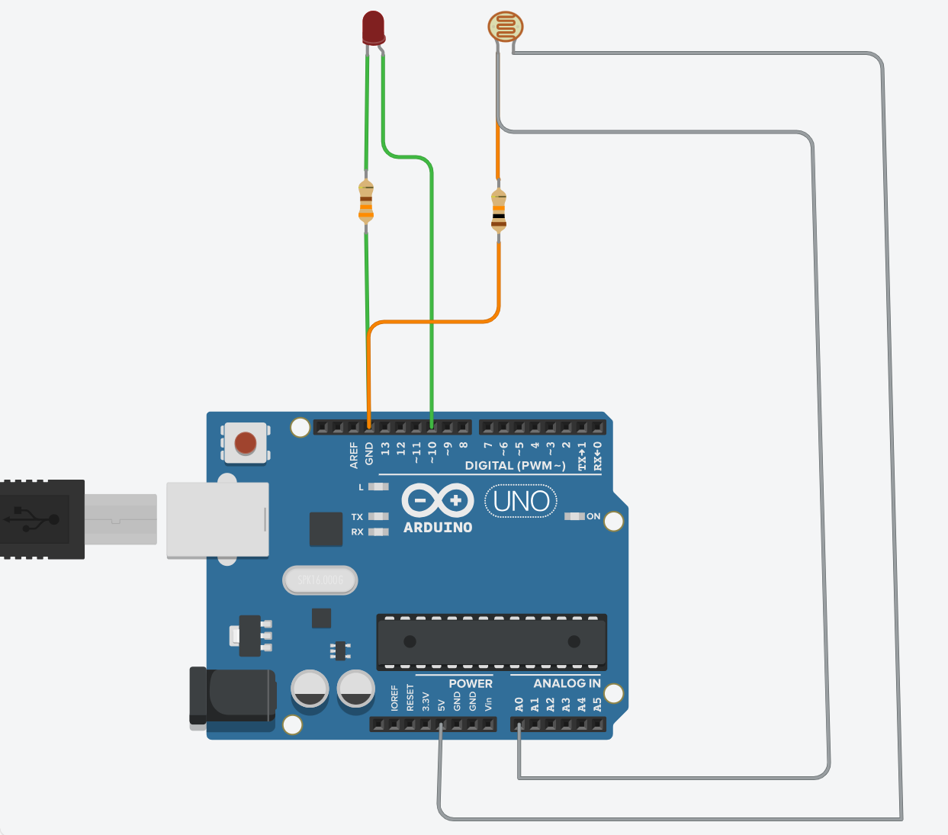

Program
// C++ code
//
int LDR_var = 0;

void setup()
{
pinMode(A0, INPUT);
Serial.begin(9600);
pinMode(10, OUTPUT);
}

void loop()
{
LDR_var = analogRead(A0);
Serial.println(LDR_var);
if (LDR_var < 500) {
digitalWrite(10, HIGH);
} else {
digitalWrite(10, LOW);
}
delay(10); // Delay a little bit to improve simulation performance
}

Working Observation:
- Initially the LED is on glowing mode, since the light intensity is less than the value 500.
- It is observed that when the light intensity increases then the LDR will increases it’s value simultaneously that can be viewed through the serial monitor.
- So, as the light intensity increases the LDR value also increases, therefore the LED which is connected in the pin D10 will stop glowing.

RESULT: smart street light system is deployed using LDR sensor successfully and executed with Arduino microcontroller Board.

